S3220A

Technical Specification

February 2021

**Version 1.0 / 04.02.2021**

**Swiss Innovation Lab® AG**

Bernstrasse 18

2555 Brügg

Switzerland

<http://www.swissinnolab.com>

Table of Contents

S3220A 1

1 Document version 2

2 System overview 3

2.1 Power supply 4

2.2 Microcontroller 4

2.3 Peripherals 4

2.4 Static consumption – peripherals turned off 6

2.5 Dynamic consumption – peripherals in sleep mode 6

2.6 Dynamic consumption – peripherals active 6

3 Firmware design guidelines 7

3.1 Microcontroller pin type, direction and polarity 7

3.2 Peripherals pin type, direction and polarity 8

3.3 Putting peripherals to low power mode 9

4 Board testing 10

4.1 Power supplies 10

4.2 Microcontroller and peripherals 10

4.3 Static consumption 10

4.4 Dynamic consumption 10

# Document version

|  |  |  |  |
| --- | --- | --- | --- |
| Version | Date | Author | New in this version |
| 1.0.0 | 04.02.2021 | Domagoj Mihalić | Draft version |
|  |  |  |  |

# System overview

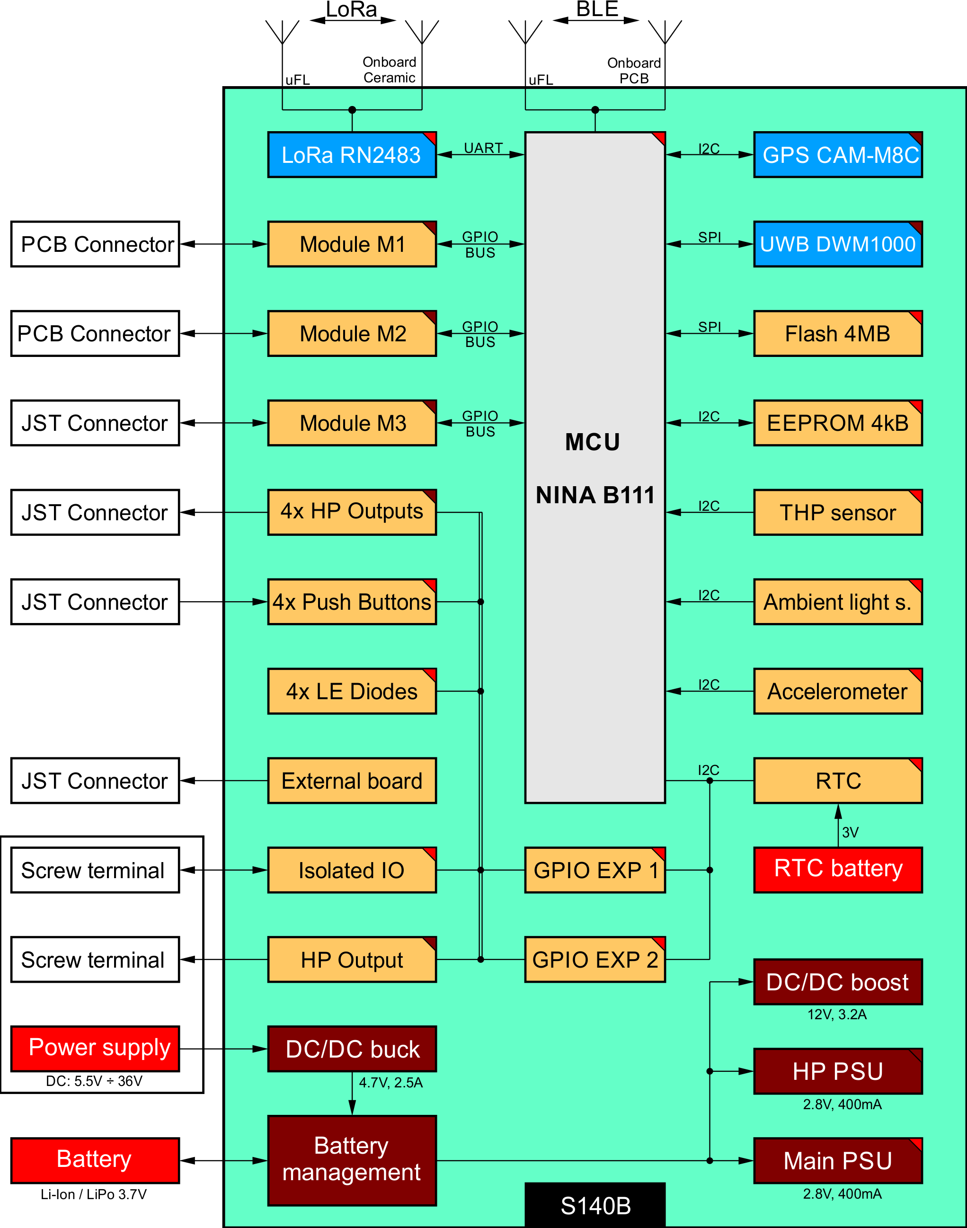

**Figure 1: PCB block diagram**

## Power supply

One battery as power supply should be provided. Used battery types can be rechargeable Li-Ion or Li-Po 3.7V or non-rechargeable batteries up to 6V. Battery capacity is not critical but should provide at least 1000mA impulse discharge currents. Rechargeable batteries should have JST 3 pole PH connectors and non-rechargeable should have JST 2 pole XH connector. Switching between rechargeable and non-rechargeable batteries is automatic on the board with protection diode. Slide switch on the edge of the board is used as main power switch. Do not use rechargeable and non-rechargeable batteries at the same time.

Charging of rechargeable batteries is done over screw terminal power supply input. Provide power supply with charging currents of at least 1A. Otherwise the charger could be damaged.

Board power supply consists of step down regulator which is active only when battery charging is active. Maximum input voltage is 36V. Battery management chip, battery protection chip and and step down power supply regulator of +2.8V are always active. Maximum current at +2.8V which regulator chip can provide is 400mA. High power supply of +2.8V can provide up to 400mA. Step up regulator for external +12V peripherals is present and can deliver up to 3.2A.

Additional power supply options are available with assembly variation of 0Ohm resistors. General overview of the power source selection diagram is given by figure 2:

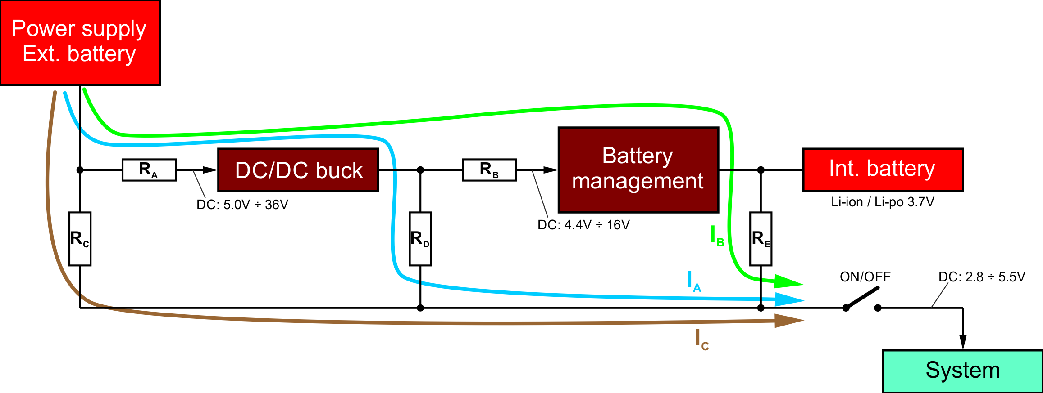

**Figure 2: Power source selection diagram**

On the S140B PCB this is done by resistors R1 (RA), R3 (RC), R10 (RD) and R119 (RB). Resistor RE is not present on the board. Detailed information about resistor selection possibilities is given in the table below:

|  |  |  |  |  |
| --- | --- | --- | --- | --- |
| **Resistor assembly combination** | | | | **Description** |
| R1 | R3 | R10 | R119 | Current direction selection resistor of 0 Ohm |
| mounted | NA | NA | mounted | Normal, +VEXT = 5.0V ÷ 36V (with internal battery) |
| NA | mounted | NA | NA | Without internal battery, +VEXT <= 5.5V |
| mounted | NA | mounted | NA | Without internal battery, +VEXT = 5.0V ÷ 36V |

Every other resistor combination could cause permanent damage to the board and is strictly forbidden!

Main PSU and high power PSU have ability to select output voltage with mounted resistor bridge selection connected to VSEL1 to VSEL4 pins. Detailed description of voltage selection is described in TPS62742 datasheet. Default selection for both voltages is 2.8V.

## Microcontroller

Board has mounted module uBlox NINA-B111 based on nRF52 microcontroller. NINAs antenna is connected to PCB antenna by default. If external antenna is required bypass antenna signal from PCB antenna to uFL connector. Connect external antenna with 50 Ohm characteristic impedance for BLE frequency bandwidth. NFC capability of the module is not used and must be turned off in firmware for proper work.

## Peripherals

Board has the following peripheral modules and sensors soldered: LoRa communication module based on RN2483A, GPS receiver based on CAM-M8C, Flash memory of 4MB, EEPROM memory of 4kB, RTC – Real Time Clock with backup battery, THP – Temperature Humidity Pressure environmental sensor, Accelerometer and Ambient light sensor, GPIO expander 1 for control of internal board signals, GPIO expander 2 for control of internal board signals and user interface signals, 4 push buttons connected to GPIO expander 2 as inputs, 4 LEDs connected to GPIO expander 2 as outputs.

There is possibility of mounting: RTLS – Real Time Location System based on UWB DWM1000 which is by default not soldered.

Module M1 has direct connection to NINA pins and is used for SIL modules which are compatible with Microbus modules. Low power +2.8V, high power +2.8V, battery connection and +5V power supplies outputs are present. Module M2 has parallel connection to M1 but is mounted on the opposite side of the board.

High power output from battery or both +2.8V sources is present. On the screw terminal one high power output with all voltages is present. On the same screw terminal 2 output and 1 input optocoupler is present. Screw terminals also provide external power supply input pins from vehicle or other source.

## Static consumption – peripherals turned off

Estimated board quiescent current by component:

* U1: 0.0 uA (USBLC6 ESD protection, powered from USB)
* U2: 0.5 uA (TPS22917 load switch)
* U3: 0.0 uA (STM32L476VGT6, not considered)
* U4: 0.5 uA (TPS22917 load switch)
* U5: 0.0 uA (eSIM card, not mounted)
* U6: 0.0 uA (SRV05-4HTG micro SIM card protection, turned off)
* U7: 0.0 uA (BG96-M3, turned off)
* U8: 0.0 uA (TXB0104 level shifter, turned off)
* U9: 0.0 uA (TXB0104 level shifter, turned off)
* U10: 0.5 uA (TPS22917 load switch)
* U11: 0.0 uA (NINA-B301, turned off)
* U12: 0.0 uA (SAM-M8Q, turned off)
* U13: 2.0 uA (M24C32 EEPROM memory, idle)
* U14: 100 nA (BME280, environmental sensor, sleep)
* U15: 6.0 uA (MMA8452 accelerometer, sleep mode)
* U16: 7.0 uA (TS3A5018 SPI MUX, idle)
* U17: 1.0 uA (W25Q32 flash memory, idle)
* Battery sense resistor divider: 0.0uA (direct feed to CPU)
* C 100nF parasitic current: 3.9uA (300nA *13)
* C 10uF parasitic current: 5.4uA (300nA *18)

Total board consumption: 26.9 uA

## Dynamic consumption – peripherals in sleep mode

Estimated board quiescent current by component:

* U3: 75 uA (TPS61087 step up, 12V, turned on)
* U5: 0.5 uA (TPS62742 step down, turned on)
* U17: 2.1 uA (LoRa turned on and in sleep mode)

## Dynamic consumption – peripherals active

Estimated board peripheral current by component:

* U9: 21 mA (NINA B111 active and transmitting)
* U10: 32 mA (CAM-M8C-0 turned on and locating)
* U17: 40 mA (LoRa turned on and transmitting data)
* U16: 170 mA (DWM1000 UWB turned on and locating)

# Firmware design guidelines

## Microcontroller pin type, direction and polarity

Use the following configuration of NINA pins. Pins direction or type are described as:

I - input direction

O - output direction

AI – analog input  
DI – digital input  
DO – digital output

NP – no pull

PU – pull up

PD – pull down

L – output low

H – output high

II IIII IIII IIOO IOOI‬ (default HW configuration, no modules attached)

││ ││││ ││││ ││││ │││└── NINA_GPIO_1  
││ ││││ ││││ ││││ ││└─── SCL (DO-NP)   
││ ││││ ││││ ││││ │└──── SDA (DO-NP)   
││ ││││ ││││ ││││ └───── nGPIO_EXP2_INT (DI-NP)  
││ ││││ ││││ │││└─────── UART_TXD_LORA (DO-PU)  
││ ││││ ││││ ││└──────── UART_RXD_LORA (DO-NP)  
││ ││││ ││││ │└───────── NINA_GPIO_20  
││ ││││ ││││ └────────── NINA_GPIO_21  
││ ││││ │││└──────────── NINA_GPIO_22  
││ ││││ ││└───────────── NINA_GPIO_28  
││ ││││ │└────────────── NINA_GPIO_29  
││ ││││ └─────────────── VBAT (AI)  
││ │││└───────────────── NINA_GPIO_17  
││ ││└────────────────── NINA_GPIO_18  
││ │└─────────────────── NINA_GPIO_23  
││ └──────────────────── NINA_GPIO_24  
│└────────────────────── NINA_GPIO_25  
└─────────────────────── NINA_GPIO_27

## Peripherals pin type, direction and polarity

Use the following configuration of GPIO expanders to turn all peripherals off.

GPIO expander 1, Address: 0x24

Chip HW configuration: O - Output “0”, I - Input "1"

1111 1111 0000 0000 (port)  
7654 3210 7654 3210 (pin)

OOOO OOOO OOOO OOOO = 0x0000 (default HW configuration, no modules attached)

LHLL HHHH HHLH LLLL = 0x4FD0 (default output configuration, no modules attached)

││││ ││││ ││││ │││└── ISO_OUT2   
││││ ││││ ││││ ││└─── ISO_OUT1   
││││ ││││ ││││ │└──── HP_OUTPUT_TERM   
││││ ││││ ││││ └───── HP_5V_PWR_CTRL   
││││ ││││ │││└─────── nFLASH_CS  
││││ ││││ ││└──────── HP_2V8_PWR_CTRL  
││││ ││││ │└───────── nGPS_PWR_CTRL  
││││ ││││ └────────── nHP_OUTPUT4  
││││ │││└──────────── nHP_OUTPUT3  
││││ ││└───────────── nHP_OUTPUT2  
││││ │└────────────── nHP_OUTPUT1  
││││ └─────────────── nUWB_PWR_CTRL  
│││└───────────────── UWB_WAKEUP  
││└────────────────── nUWB_RST  
│└─────────────────── nLORA_PWR_CTRL  
└──────────────────── nLORA_RST

GPIO expander 2, Address: 0x20

Chip HW configuration: O - Output “0”, I - Input "1"

1111 1111 0000 0000 (port)  
7654 3210 7654 3210 (pin)

IIII OOOO IIII IIII = 0xF0FF (default HW configuration, no modules attached)

HHHH HHHH LLHL HHHH = 0xFF2F (default output configuration, no modules attached)  
││││ ││││ ││││ │││└── ISO_IN1  
││││ ││││ ││││ ││└─── nACCELEROMETER_INT1  
││││ ││││ ││││ │└──── nAMBIENT_INT  
││││ ││││ ││││ └───── nRTC_INT  
││││ ││││ │││└─────── GPS_EXTINT  
││││ ││││ ││└──────── nGPIO_EXP1_INT  
││││ ││││ │└───────── UWB_IRQ  
││││ ││││ └────────── UWB_EXTON  
││││ │││└──────────── nLED_1  
││││ ││└───────────── nLED_2  
││││ │└────────────── nLED_3  
││││ └─────────────── nLED_4  
│││└───────────────── nPB_1  
││└────────────────── nPB_2  
│└─────────────────── nPB_3  
└──────────────────── nPB_4

## Putting peripherals to low power mode

When not used peripherals should be disconnected from power supply. If the peripheral is used it should be put to low power mode with its communication protocol.

# Board testing

## Power supplies

Resistor R107 must be removed from BOM. R107 generates constant parasitic current of 2.8 uA.

~~All power supplies and battery management are working as expected.~~

## Microcontroller and peripherals

The following has to be documented.

## Static consumption

## Dynamic consumption

The following has to be documented.